AOC-0 / R-1 Flight operations manual
Suborbital procedures and checklists
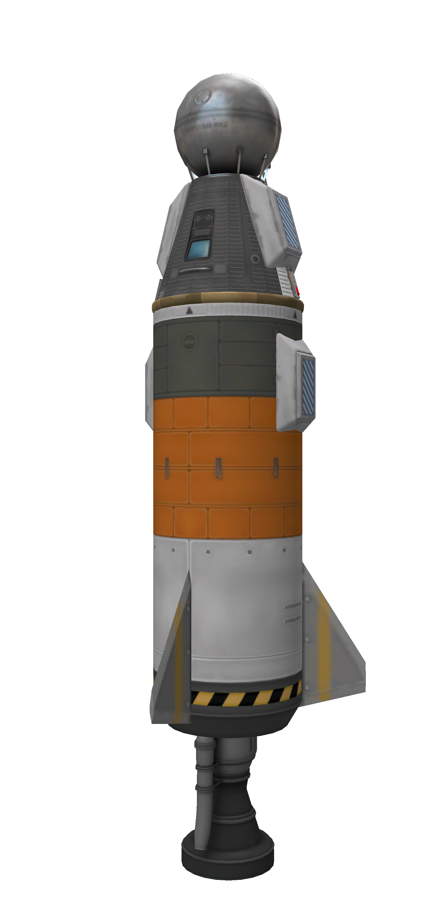

About this document
This document describes the procedures to be used during a AOC-0 suborbital mission. This mission requires an R-1 launcher and all known mission variants are described in this document. This document also contains the checklists and actions to be taken under unusual and emergency circumstances.

Table of Contents
About this document 2
Mission types 4
Final assembly 4
Quality control steps 4
Quick turnaround procedure 4
Suborbital exo AOC-0 launch profile 5
Flight parameters 5
Equipment loadout 5
Pre-rollout check 5
In flight checklists and procedures 6
SYSTEM LIST (CAPSULE) 6
SYSTEM LIST (BOOSTER) 7
MINIMUM EQUIPMENT LIST 7
NORMAL PROCEDURES 8
Pre flight 8
Launch 8
Mission specific emergency procedures 9
Booster LFOX tank failure (boost phase) 9
Suborbital precision AOC-0 launch profile 10
Flight parameters 10
Equipment loadout 10
Pre-rollout check 10
In-flight checklists and procedures 10
NORMAL PROCEDURES 10
Pre flight 10
Launch 10
EMERGENCY PROCEDURES 12
General emergency procedures 12
Pod battery failure 12
Pod parachute failure (single) 12
Booster engine failure 12
Booster LFOX tank failure (boost phase) 12
Booster decoupler failure 12
Pod parachute failure (dual) 12
Heat shield jettison failure 13
Attached re-entry 13
Crew parachute re-entry 13
Tourism mission additional emergency checklists 14
Computer battery failure 14
Radio failure (single) 14

Mission types
There are 3 known mission types for the AOC-0 in a suborbital configuration: exo-atmospheric exploration, precision targeted launch and exo-atmospheric tourism. Both exo-atmospheric missions types are similar, with the tourism mission having an unqualified tourist instead of a qualified crewman.

Final assembly
Mount AOC-0 capsule on top of decoupler.
Parachutes should align to R-1 parachutes
Hatch should align with R-1 gas generator exhaust
Hatch should align with R-1 fin
Orient capsule/booster stack with capsule hatch pointing towards desired direction of gravity turn
Usually east
AOC-0 causes booster to tilt towards hatch side
Re-root to Mk1 Command pod
Staging should be set to decouplers and parachutes in stage 0 and engine in stage 1.

Quality control steps
If the decoupler has been separated from the booster, ensure that it is reconnected to the booster and capsule. It the decoupler is connected to the heat shield and the booster is then connected to the capsule, it is possible that the booster ends up connected directly to the heat shield via the second node in the heat shield, making it impossible to separate. This can be seen when the booster causes the shroud to appear around the heat shield despite the decoupler being connected to the heat shield.

Quick turnaround procedure
After a suborbital mission and recovery of booster and capsule.
- Mate capsule and booster
- Charge capsule battery
- Enable decoupler staging
- Charge propellants on booster
- If capsule batteries were drained, recharge computer battery.
Consider having an extra capsule ready for use. If the capsule has been serviced prior to mating, the KCT turnaround time is reduced from 1 hour and 20 minutes to 37 minutes.

Suborbital exo AOC-0 launch profile
This profile is essentially a vertical flight up to the limits of the Kerbin atmosphere. Booster is ejected as soon as the craft leaves the atmosphere and the craft and booster are automatically recovered via passive mechanisms.

Flight parameters
Launcher R-1
Max altitude 105Km
Vertical flight

Equipment loadout
None. Remove resources and leave stores are indicated below.
Resource | Amount | Units | Notes
Electrical charge | FULL | EC
Spare parts | 0 | Units | Mission too short for repairs
Food | EMPTY | % | LS is not an issue for short flights
Water | EMPTY | % | LS is not an issue for short flights
Oxygen | EMPTY | % | LS is not an issue for short flights
Carbon Dioxide | EMPTY | % | Should not need to be drained
Waste water | EMPTY | % | Should not need to be drained
Waste | EMPTY | % | Should not need to be drained
Pilot should carry a parachute in exploration missions. Tourism missions do not carry parachutes (they actually do, but cannot use them).
Life support is not necessary in suborbital missions because missions are shorter than 15 minutes while kerbals can survive 2 hours without oxygen (breathing the air in the capsule, I suppose). After the 15 minute flight, air is taken from Kerbin’s atmosphere, extending endurance. The limit is 18 hours because of lack of water. Recovery should be performed within that time.

Pre-rollout check
- Verify equipment loadout
  - No spare parts
  - No monopropellant
  - Life support EMPTY
  - Waste EMPTY
  - Pilot carries parachute, tourists do not
  - No EVA jetpack
- Verify R-1 propellant levels
  - Fully loaded
- Verify R-1 parachute parameters
  - Pressure 0.6
  - Altitude 500
  - Angle 10
  - Open when safe
- Verify AOC-0 parachute parameters
  - Pressure 0.6
  - Altitude 750
  - Angle 10
  - Open when safe
- Verify electrical system
  - Fully charged, both in Stayputnik and Mk1 pod
  - EC flow set to 0 in Mk1, -1 in Stayputnik, priority goes to Mk1
- Verify that booster decoupler is stageable
- Verify that no Dangit reports indicate damage
- Verify staging
  - Engines on stage 1
  - Parachutes and decoupler on stage 0

In flight checklists and procedures

SYSTEM LIST (CAPSULE)
Pod
Reaction wheel
Lights
Battery
Part storage bin
Food storage
Water tank
O2 tank
CO2 tank
Waste tank
Wastewater tank
Computer
Battery
Parachute (L)
Parachute (R)
Radio (L)
Radio (R)
Thermometer
Barometer
Heat shield
Shield
Ejector

SYSTEM LIST (BOOSTER)
Engine
Fins
LFOX tanks
Parachutes
Decoupler

MINIMUM EQUIPMENT LIST
Capsule
Pod
Wheel
Battery
Parachute (L)
Parachute (R)
Heat shield
Ejector
Radio x 2 (tourism only)
Booster
Engine
Fins
LFOX tanks
Parachutes x1
Decoupler

NORMAL PROCEDURES

Pre flight
Computer hibernate OFF
Radios ON
Computer EC FULL
Pod EC FULL
LFOX Tanks FULL
Decoupler STAGEABLE
DANGER: Launching with an unstageable decoupler requires an attached landing which is a potentially deadly situation
Pod Parachutes CHECK PARAMS (0.6/750/10)
Rocket Parachutes CHECK PARAMS (0.6/500/10)
Throttle MAX
Capsule hatch Oriented east unless otherwise required
DANGER: Launching with the hatch oriented west from KSC may result in capsule landing in mountains
FMRS is not necessary, capsule and booster remain in close proximity during the flight

Launch
Set KER to orbit + surface + land
Landing pointer shows estimated landing position
Perform pre-flight checklist
Stage to start engine
Rocket will veer towards hatch side
Hatch-side forces increase until shortly before MECO
Landing point can be placed within a 25Km circle around KSC by rotating and tilting rocket
Tilt rocket after MECO for final adjustments
At 70 KM
Stage
Capsule lands automatically upon reentering atmosphere. Booster lands before capsule. Recovery process can start immediately.

Mission specific emergency procedures
These procedures are specific for this type of mission only and may be used instead of the general procedures.

Booster LFOX tank failure (boost phase)
Continue burn until propellants are exhausted.
At 70 Km or at apoapsis (if lower):
Stage
Proceed with mission normally.

Suborbital precision AOC-0 launch profile
This profile sacrifices altitude for additional control. Booster is kept until propellants are exhausted and is used to guide the craft to a specific landing point. The craft and booster are automatically recovered via passive mechanisms after decoupling.

Flight parameters
Launcher R-1
Max altitude Variable
Angled flight in lower/mid atmosphere. May reach high atmosphere.

Equipment loadout
Equipment loadout is identical to exo-atmospheric loadout.

Pre-rollout check
The pre-rollout check is identical to the exo-atmospheric check.

In-flight checklists and procedures
System list, and minimum equipment list are identical to exo-atmospheric checks. No provision is made for tourism flights in this regime.

NORMAL PROCEDURES

Pre flight
Computer hibernate OFF
Radios ON
Computer EC FULL
Pod EC FULL
LFOX Tanks FULL
Decoupler STAGEABLE
Pod Parachutes CHECK PARAMS (0.6/750/10)
Rocket Parachutes CHECK PARAMS (0.6/500/10)
Throttle MAX

Launch
Set KER to orbit + surface + land
Landing pointer shows estimated landing position
Use SCANSat screen or map with estimated landing point to estimate error in reaching target
Perform pre-flight checklist
Stage to start engine
Rotate and tilt rocket to guide landing indicator to desired landing point
Rocket will veer towards hatch side
Immediately after launch, rotate to point hatch to landing point and pitch over towards target
Cut thrust as soon as the estimated landing site is close to the target
Overshoot if survey is at high altitude
Tilt to 30 degrees from vertical for maximum range
In the lower atmosphere, use rocket thrust to compensate for drag
As soon as a proper trajectory is achieved, decouple booster.
Capsule lands automatically close to target. Booster lands before capsule. Recovery process can start immediately.

EMERGENCY PROCEDURES
These procedures should be followed in case of unexpected events or damage to the spacecraft and are common to all suborbital operation modes.

General emergency procedures

Pod battery failure
Engine Thrust CUT
Staging ACTIVATE
Return to kerbin

Pod parachute failure (single)
Engine Thrust CUT
Staging ACTIVATE
Return to kerbin

Booster engine failure
Engine Thrust CUT
Staging ACTIVATE
Return to kerbin

Booster LFOX tank failure (boost phase)
Engine Thrust CUT
Staging ACTIVATE
Return to kerbin

Booster decoupler failure
Staging ACTIVATE
Decoupler MANUAL DECOUPLE
Verify parachute state (capsule) DEPLOYED
Verify parachute state (booster) DEPLOYED
Pod heat shield JETTISON

Pod parachute failure (dual)
Engine Thrust CUT
Conserve propellants and limit apoapsis as much as possible.
Option 1: Decouple and eject in the lower atmosphere, landing by personal parachute.
Option 2: Follow attached re-entry checklist.
Option 1 should be taken if apoapsis is above 55 KM. Option 2 should be taken if option 1 is undesirable or impossible or if large amounts of propellant are available in the booster’s tanks.

Heat shield jettison failure
Verify parachute state (capsule) DEPLOYED
Verify parachute state (booster) DEPLOYED
Decoupler MANUAL DECOUPLE
If decouple unsuccessful, follow attached re-entry checklist.

Attached re-entry
Thrust CUT
Capsule parachutes RECONFIGURE
Pressure 0.01
Altirude 5000
Open when risky
Booster parachutes RECONFIGURE
Pressure 0.01
Altirude 5000
Open when risky
Before apoapsis:
Attitude MAX DRAG (nose to horizon)
After apoapsis:
Above 30 KM
Attitude MAX DRAG
30 to 19 KM
Attitude SURFACE RETROGRADE
At 19 KM altitude, burn to reduce velocity to below 500 m/s.
When parachutes open, burn to keep velocity below 300 m/s for as long as possible.
Prevent nose down attitude at all costs.

Crew parachute re-entry
Remain in capsule until atmospheric re-entry is complete.
Wait until 9 KM altitude and 280 m/s speed is reached.
Perform EVA. Crewman should be dragger by airflow.
When terminal velocity of 60 m/s is reached, deploy parachute. Parachute should open instantly.
Configure parachute to 2500 M full opening.
When parachute opens, glide towards rescue point. Vertical speed should be 3.5 m/s and 20 m/s horizontal speed.
At 5 M above terrain, flare parachute to lose horizontal speed to less than 10 M/s and land.

Tourism mission additional emergency checklists
These checklists are in force in addition to the ones in the exploration mission. Any condition listed here should be acted upon.

Computer battery failure
Engine Thrust CUT
Staging ACTIVATE
Return to kerbin

Radio failure (single)
Engine Thrust CUT
Staging ACTIVATE
Return to kerbin

